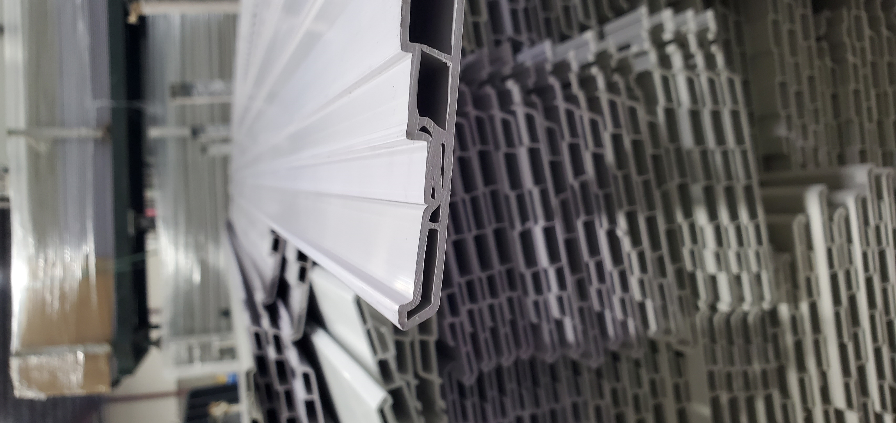

QUALITY ALERT

Customer: ChamClad Date: October 04, 2022
Die: 15766 Customer NCR:
Type of Complaint: ChamClad REJECT

Description: ChamClad REJECTED – Material has wall is collapsed.

BAD

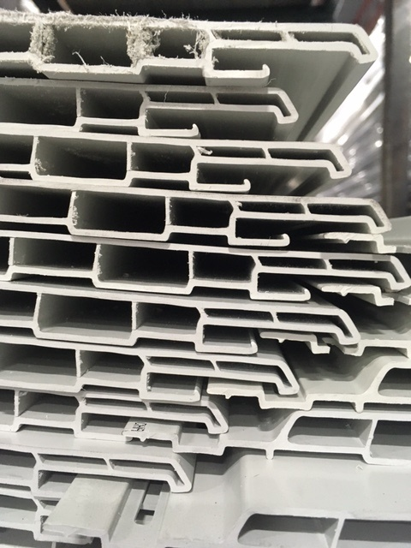

GOOD
MAKE SURE MATERIAL RUN GOOD SHAPE
BY SIGNING BELOW, YOU ACKNOWLEDGE THE PROBLEM ABOVE AND AGREE TO MONITOR THIS ISSUE IN FUTURE PRODUCTION RUNS.
DAY SHIFT |  | AFTERNOON SHIFT |  | NIGHT SHIFT
NAME | SIGNATURE | NAME | SIGNATURE | NAME | SIGNATURE

